**Ideation Phase**

**Brainstorm & Idea Prioritization Template**

|  |  |
| --- | --- |
| Date | 19 September 2022 |
| Team ID | PNT2022TMID07118 |
| Project Name | Project - A Gesture-based Tool for Sterile Browsing of Radiology Images |
| Maximum Marks | 4 Marks |

**Brainstorm & Idea Prioritization Template:**

Brainstorming provides a free and open environment that encourages everyone within a team to participate in the creative thinking process that leads to problem solving. Prioritizing volume over value, out-of-the-box ideas are welcome and built upon, and all participants are encouraged to collaborate, helping each other develop a rich amount of creative solutions.

Use this template in your own brainstorming sessions so your team can unleash their imagination and start shaping concepts even if you're not sitting in the same room.

Reference: <https://www.mural.co/templates/empathy-map-canvas>

**Step-1: Team Gathering, Collaboration and Select the Problem Statement**

**Step-2: Brainstorm, Idea Listing and Grouping**

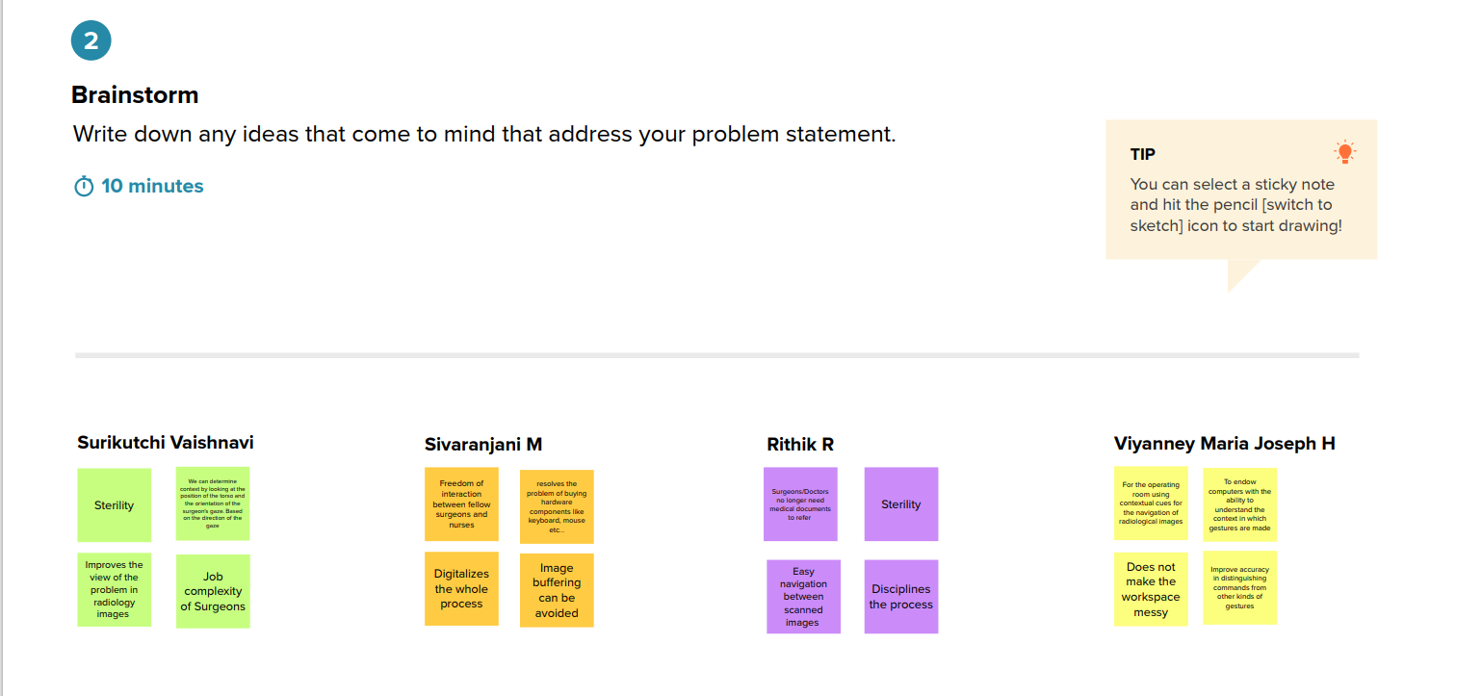

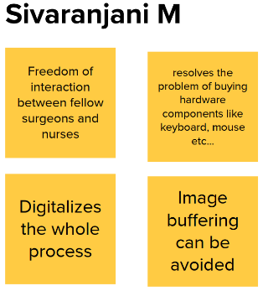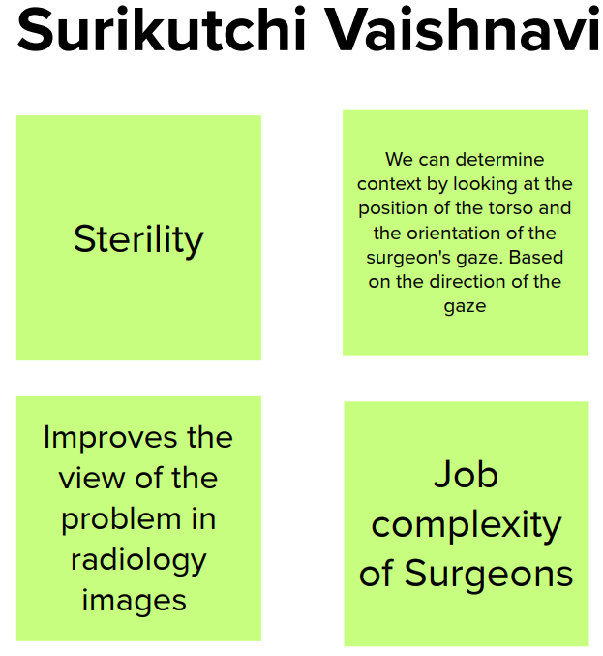

**Step-3: Idea Prioritization**

